### **Data dictionary:**

### **Analyzing Pre-Order Decline on Electric Vehicle Manufacturer's Website**

**Schema**

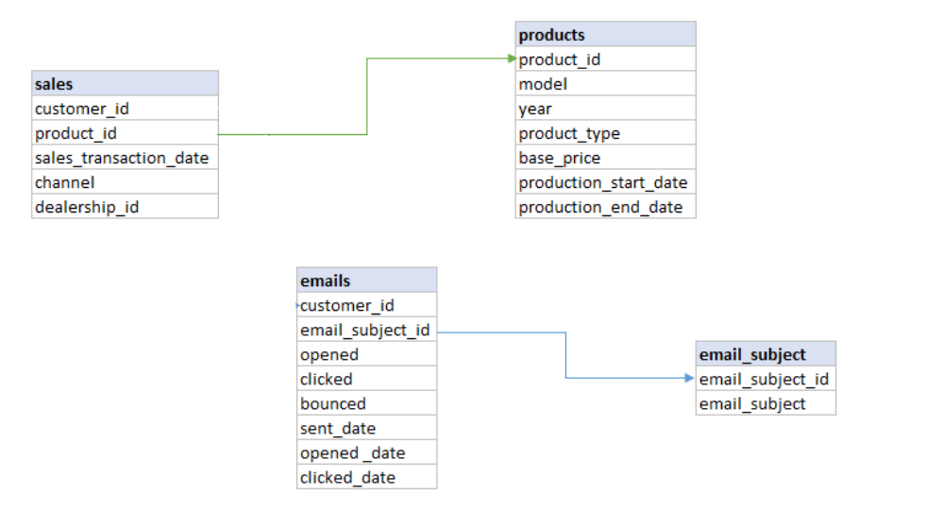

Table : **sales**

it records all the sales transactions of company products

| **column** | **Data type** | **Explanation** |
| --- | --- | --- |
| customer_id | INT | Each and every customers logged in on Zoom Electric are assigned a unique identifier |
| product_id | INT | ids of products |
| sales_transaction_date | TIMESTAMP | date of sales transactions done for product ids |
| channel | VARCHAR | sales channel ( offline or online) offline - dealers across the various cities |
| dealership_id | INT | Code of dealer through which sales done |

Table : **products**

it details about the products manufactured by the company, it includes details of model and date and year of production stars

| **column** | **Data type** | **Explanation** |
| --- | --- | --- |
| product_id | INT | Primary Key for the product table ( unique identifiers for Zoom Electric products |
| model | VARCHAR | Model for the products |
| year | INT | Model Year for the products |
| product_type | VARCHAR | Type of products - scooter , automobile |
| base_price | FLOAT | price of the products |
| production_start_date | TIMESTAMP | Date on which production of the product starts in Zoom Electric |
| production_end_date | TIMESTAMP | Date on which production of the product end or closed in Zoom Electric |

Table : **emails**

All the campaign related email sent to the customers

| **column** | **Data type** | **Explanation** |
| --- | --- | --- |
| email_id | INT | Primary Key for the email table ( unique identifiers for all the email sent to customers) |
| customer_id | INT | Customer id |
| email_subject_id | VARCHAR | subject of the email |
| opened | BOOLEAN | Check if email opened or not , 1- opened else not opened |
| clicked | BOOLEAN | 1- clicked else not clicked |
| bounced | BOOLEAN | 1- bounced , 0- not bounced |
| sent_date | TIMESTAMP | Date on which email was sent |
| opened _date | TIMESTAMP | Date o which email was opened |
| clicked_date | TIMESTAMP | Date on which customer clicked the link to land the ZOOM ELECTRIC landing page |

**Table email_subject**

it list out all the campaign related email subject

| **column** | **Data type** | **Explanation** |
| --- | --- | --- |
| email_subject_id | VARCHAR | Primary Key for the email subjects |
| email_subject | VARCHAR | Descriptions of emails |